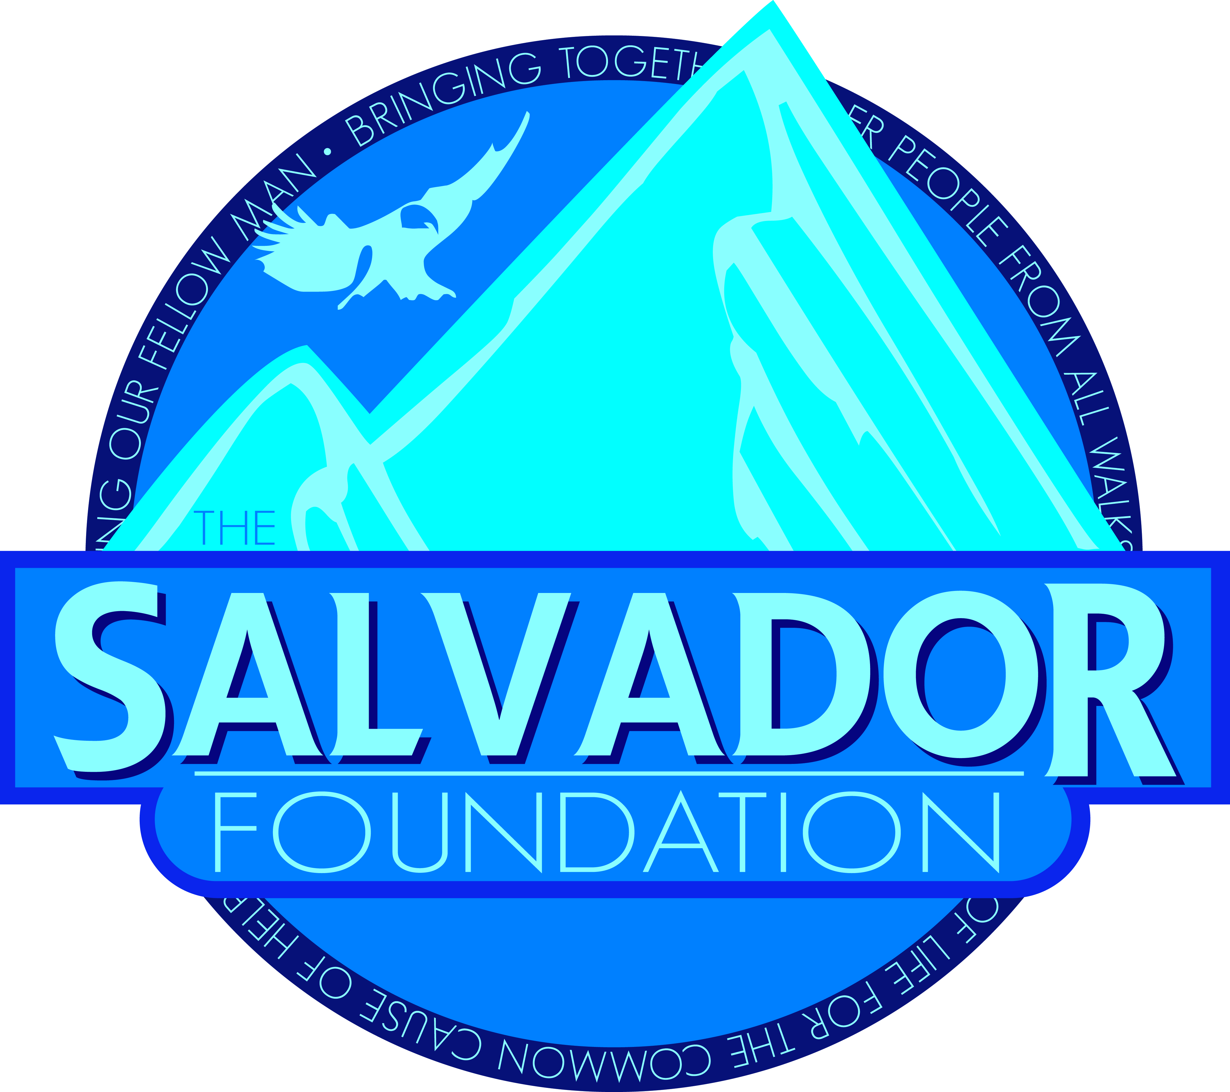

***3rd Quarter 2014 Newsletter***

*The Salvador Foundation is committed to serving God by bringing together people from all walks of life for the common cause of helping our fellow man. We, as the body of Christ, have a responsibility to care for those in need. By helping and enabling people one project at a time, our goal is to share encouragement, hope and faith.*

More than a million times a year, a terminally ill patient in the United States is enrolled in hospice care. Each time, the family confronts a decision that, while critical, often must be made almost blindly.

More than a thousand new hospices have opened in the United States in the past decade, and many of them operate on a for-profit basis. But the absence of public information about their quality, a void that is unusual even within the health-care industry, leaves consumers at a loss to distinguish the good from the bad.

Though the federal government publishes consumer data about the quality of other health-care companies, including hospitals, nursing homes and home health agencies, it provides no such information about hospices.

The absence of information forces families to speculate and hope for the best — to roll the dice — when choosing medical care for a loved one facing death.



It also allows hospices that offer poor service to escape detection, while the care at better hospices goes unrecognized. According to a battery of Medicare statistics, some appear to be offering scant care: 18 percent of hospices do not provide continuous nursing care or inpatient care for patients in crisis; a similar proportion regularly fail to have a registered nurse visit the patient in the 48 hours before death; and at hundreds of hospices, more than a third of patients drop hospice services before death — a sign that the patients may not have been getting adequate care.

The reasons that some hospices skimp on care may be at least partly financial. Medicare, the chief source of industry revenue, pays hospice companies per day of care — about $155 for a “routine” day — regardless of how much care is actually provided. That means that the less a hospice spends on nursing and other services, the more it can profit, and in some cases that business model means turning patients away because their Medicaid payments do not meet profitability requirements.

To address this need, the Salvador Foundation has partnered with Pikes Peak Hospice & Palliative Care in Colorado Springs. Pikes Peak Hospice has served our community since 1980.  While much has changed over that time, the common core value that has kept Pikes Peak Hospice running is the belief that every patient and family deserves expert care and compassionate personal attention, and that the quality of medical care should not be dependent upon profitability.

Pike Peak Hospice is the only nonprofit, community-based hospice in El Paso County. In contrast to for-profit organizations, Pikes Peak Hospice operates a non-profit Foundation which provides funding to supplement medical care where Medicare and Medicaid fall short.

Every year, Pikes Peak Hospice provides relief, comfort and control to more than 1,500 patients and their families.

Here are just a few things that set Pikes Peak Hospice and its charitable sister organization apart:

* Comprehensive team of [hospice](http://www.pikespeakhospice.org/patients-and-families/hospice-care) and [palliative](http://www.pikespeakhospice.org/patients-and-families/palliative-care-options) experts including physicians, nurse practitioners, nurses and certified nursing assistants, counselors, chaplains, pharmacists and administrative professionals
* Over 600 trained support [volunteers](http://www.pikespeakhospice.org/volunteer)
* Fast response and 24/7 access to care
* The only dedicated hospice [inpatient care unit](http://www.pikespeakhospice.org/patients-and-families/hospice-care/inpatient-care-unit)in El Paso County
* The only hospice-owned [pharmacy](http://www.pikespeakhospice.org/patients-and-families/palliative-pharmacy) in the region--specializing in hospice and palliative needs
* A comprehensive [grief counseling](http://www.pikespeakhospice.org/patients-and-families/grief-support)program, including specialized care for [children](http://www.pikespeakhospice.org/patients-and-families/grief-support/children) and teens

The Salvador Foundation is honored to play a small part in the Pike Peak Hospice team.

The Salvador Foundation is currently supporting efforts in the US and Latin America. If you would like further information on this or any other activities, please contact:

**The Salvador Foundation**

**Colorado Springs, CO 80919**

**www.SalvadorFoundation.com**